1. (b). 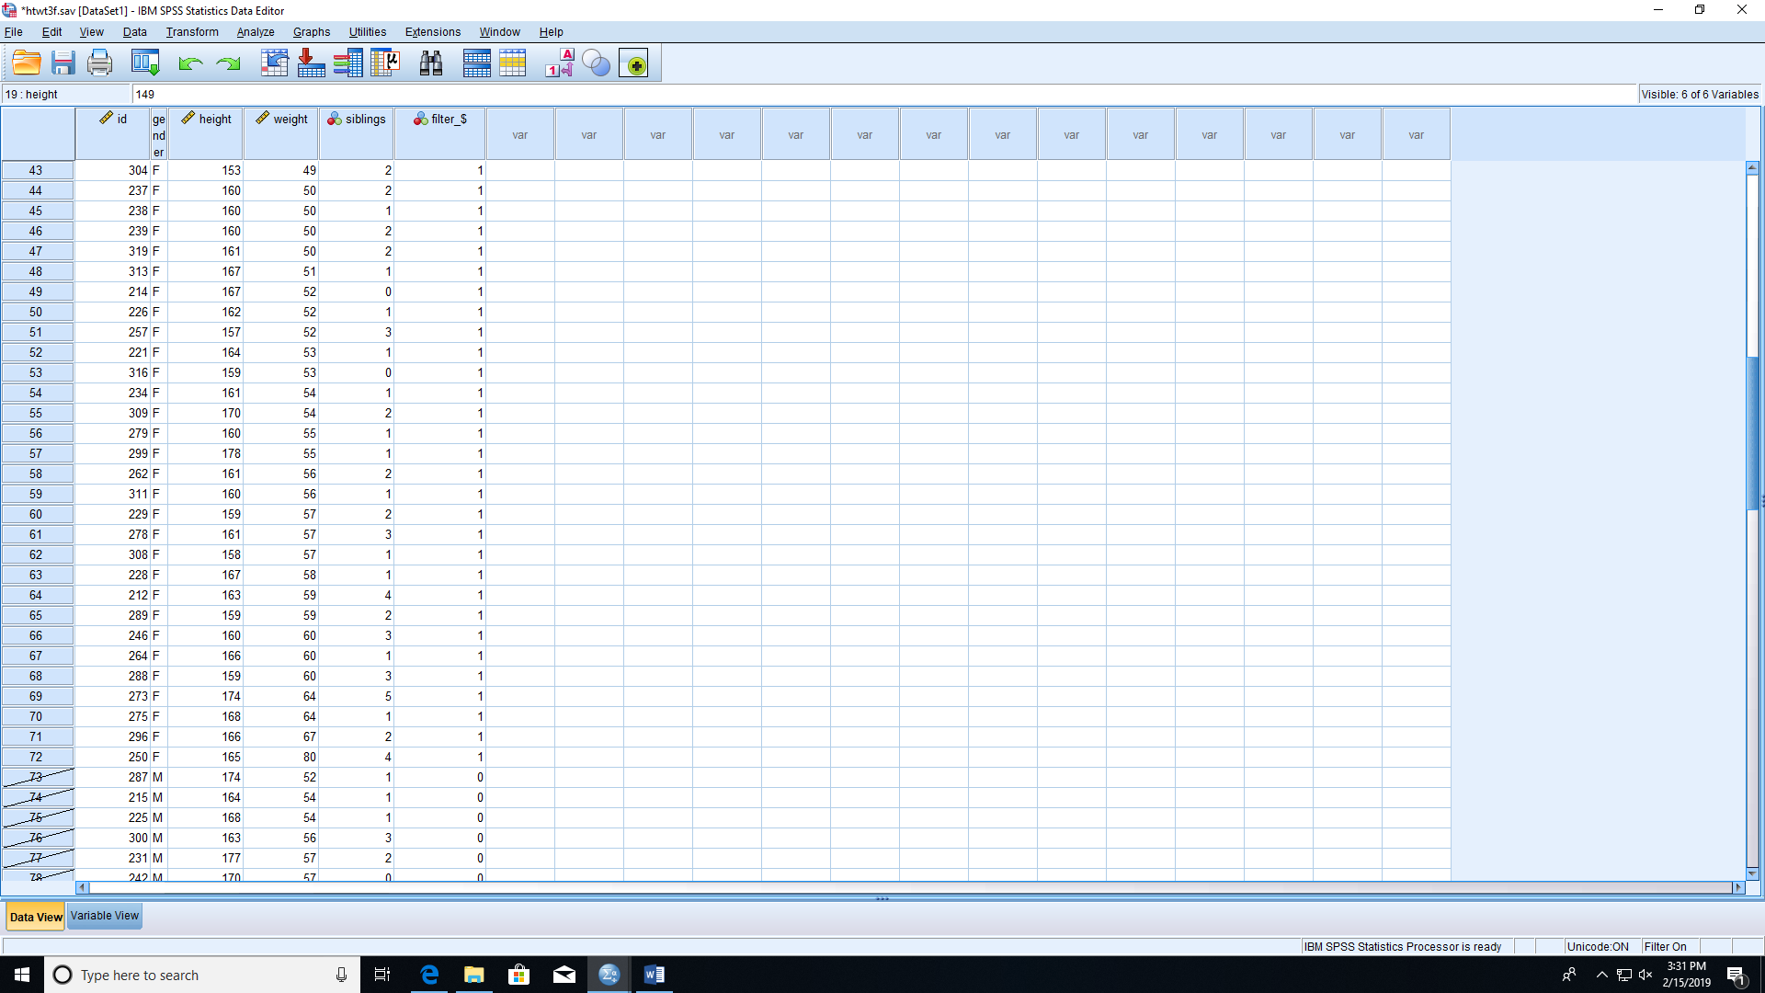

(c). Merge by add variables, then sort in the call.

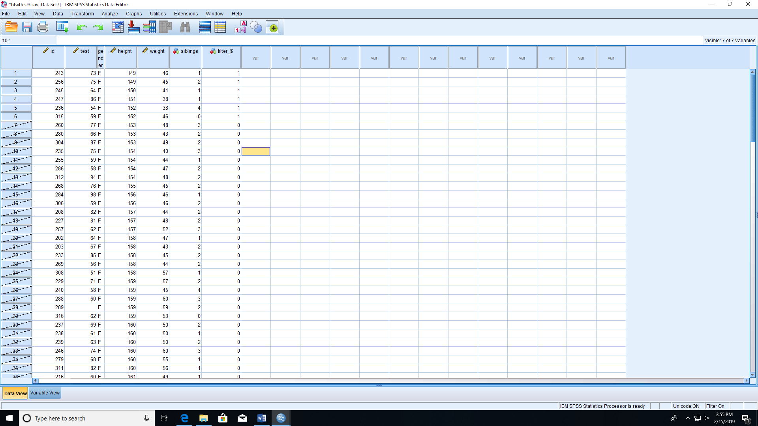

The test scores are 73, 75, 64, 86, 54, 59 in ascending order of heights.

(d).

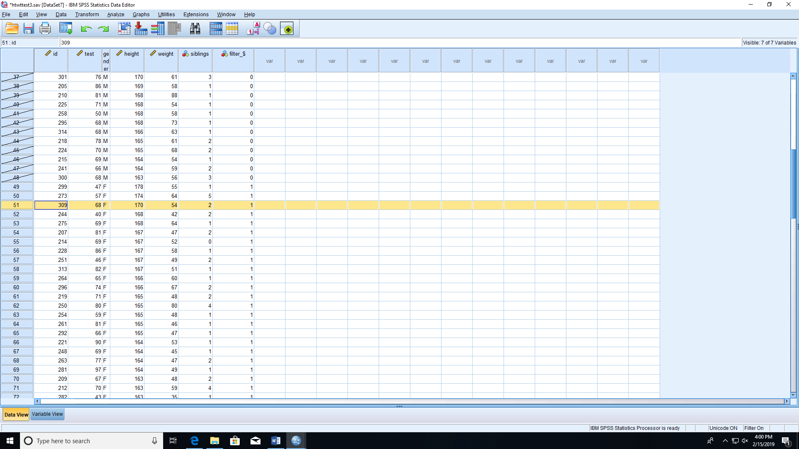

The 3rd tallest female has height 170, weight 54, test score 68.

(e). 54 got B.

(f).

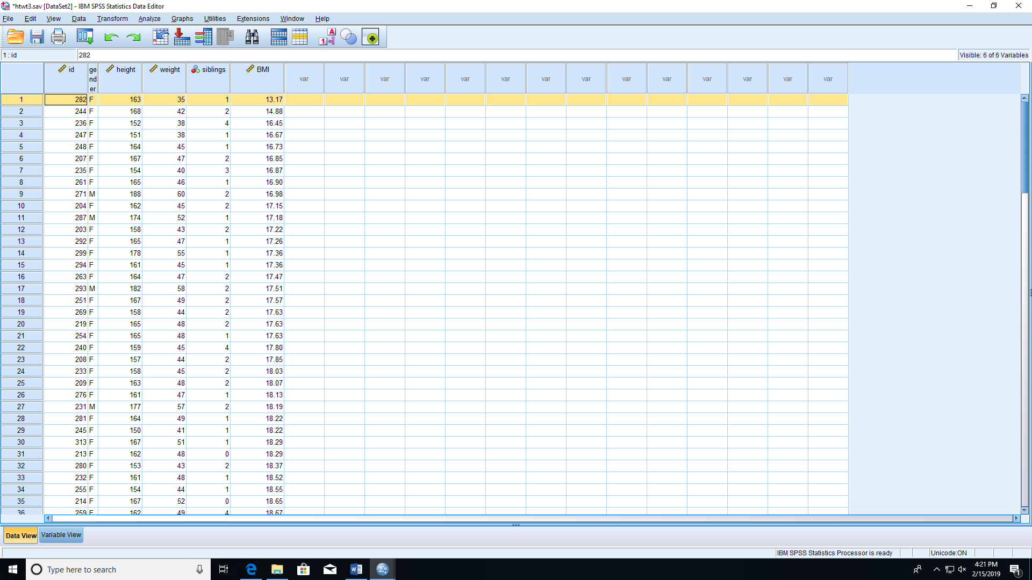

Subject 282 has the smallest BMI of 13.17.